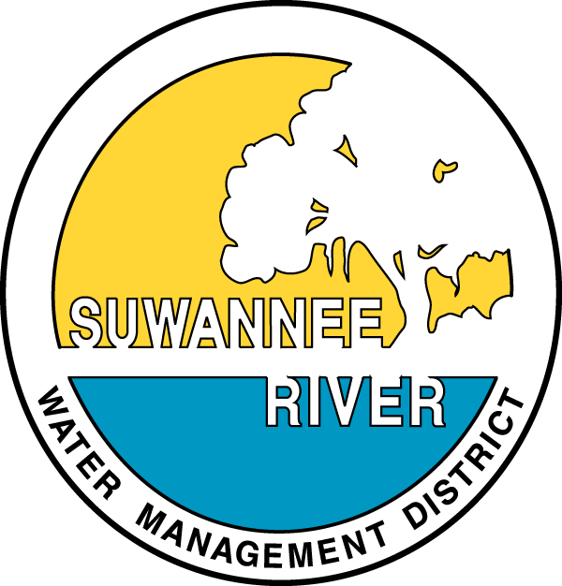
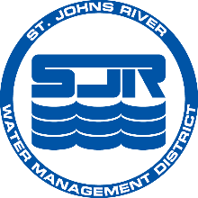
St. Johns, Suwannee River governing boards approve first-ever water supply plan for north Florida

Contact:
Communications Office Communications Office
Teresa Monson Katelyn Potter
tmonson@sjrwmd.com katelyn.potter@srwmd.org
904-730-6258 office 386-362-1001 office
904-545-5064 cell 386-208-0449 cell

PALATKA, Fla., Jan. 17, 2017 — The governing boards of the St. Johns River and Suwannee River water management districts on Jan. 17 jointly approved a 20-year plan to protect the sustainability of water supplies and identify potential future water supply sources. Approval of the North Florida Regional Water Supply Plan completes a four-year public process and the first-ever joint planning effort between the two agencies and the Florida Department of Environmental Protection (DEP).
“This has been a great partnership that has culminated in a realistic plan that will help guide us in our work to ensure sustainable water supplies in the region,” said St. Johns River Water Management District Executive Director Dr. Ann Shortelle. “I am so proud of everyone who has worked hard to bring us to this point, especially our volunteer Stakeholder Advisory Committee and our staffs. This plan is not the end — it’s a beginning.”
“This plan serves as powerful roadmap for providing our communities with water conservation savings of almost 50 percent of the projected water supply need for 2035,” said Noah Valenstein, executive director for the Suwannee River Water Management District. “Backed by the strength of our regulatory programs, which ensure no harm to our natural resources, this plan gives us the tools we need to seek funding and plan projects to accommodate growth while ensuring the protection of our water supply.”
"DEP is proud to collaborate with the St. Johns and Suwannee river water management districts as well as our partners in local government, utilities, agriculture and other industries, and the environmental community to ensure a safe and sustainable water supply for our residents," said DEP Secretary Jon Steverson. “I commend the hard work of all who participated in this process and thank them for their efforts in the completion of this important task.”
The approved plan is a result of collaboration between a multitude of stakeholders from a variety of groups, organizations and entities from both water management districts that have an interest in the region’s water supply, including agriculture, commercial/power generation, environmental advocates, industrial/mining, local governments and public water suppliers.
“Collaboration and engagement with community stakeholders on the water supply plan represents a key strategic priority for PCS Phosphate – White Springs,” said Terry Baker, Senior Director, Environmental and Mine Development for PCS Phosphate – White Springs and SAC member. “We are thankful for the rigor and planning completed by both districts to ensure water resources are available and sustainable for all users in the area.”
“The heart and spirit of this area is dependent on the well-being of our rivers, lakes and springs,” said James Cornett, owner of Spirit of the Suwannee Music Park and Campground and SAC member. “This plan is a great first step in this process to safeguard our precious resources and way of life.”
“Sound modeling and data collection is the foundation for successful planning and is the bedrock of the regional water supply plan,” said Tom Harper, owner of Harper Farms and member of the SAC committee. “The aptitude and expertise of the advisory committee, modeling technical team and district staff is evident through this tremendous collaboration and critical to the sustainability of our resources.”
“Our area’s rural communities depend on the knowledge and skill of our water management districts to guide water projects and planning that make certain water is available now and in the future,” said Gene Higginbotham, Dixie County Commissioner and SAC member.
“The proposed Regional Water Supply Plan represents a very important initial step toward ensuring the long-term sustainability of our water supply,” said Michael O’Berry, manager of Environmental Services–Southeast Division, Vulcan Materials Co. and SAC member. “While not perfect, it nonetheless establishes a basis and framework for actions to be taken to achieve sustainability of the water resource. In addition, it is anticipated that over time the assessment methods utilized to determine the current and projected future status of the water resource will be improved and refined to improve decision making and thereby influence water resource and water supply development and water conservation efforts. It was an honor to be part of the four-year process that has resulted in the creation of the first ever Regional Water Supply Plan for North Florida.”
“The water supply plan represents a tremendous feat for the ability of stakeholders with divergent, even competing interests, to rally around a common goal – safeguarding water supply for future needs,” said Jacqui Sulek with the Audubon Society of Florida and SAC member. “This plan is not the end but the beginning and future collaboration will be critical to addressing the water needs of both the environment and the people of North Florida.”
“Projecting North Florida’s water needs is critical to all users,” said Charles Shinn, government and community affairs director for the Florida Farm Bureau Federation. “Agriculture is a major economic driver in the planning region and this plan offers a variety of options to our industry to support a healthy water supply as we move forward.”
“The plan’s project concepts range from identifying traditional water supply, reclaimed water and stormwater projects to increased water conservation,” said Nancy Kilgo Veasey, JEA’s director of government relations and SAC member. “The plan also allows for innovative alternative water supply technologies to ensure water for our regions’ future growth. JEA was very actively involved in the water supply planning process with the districts’ stakeholders and was able to provide a range of projects to include on the project list.”
The plan constitutes an evaluation of how much water is needed in the year 2035 and whether the traditional sources of fresh groundwater can meet the future water demand while protecting the water resources and related natural systems, such as springs and wetlands. Where traditional water sources are not adequate, the plan identifies more than 200 million gallons per day (mgd) of water conservation, water resource development and water supply development project options to meet the 2035 projected increase in demand of 117 mgd.
The approved plan can be reviewed and downloaded from www.northfloridawater.com.
About the St. Johns River Water Management District
St. Johns River Water Management District staff are committed to ensuring the sustainable use and protection of water resources for the benefit of the people of the district and the state of Florida. The St. Johns River Water Management District is one of five districts in Florida managing groundwater and surface water supplies in the state. The district encompasses all or part of 18 northeast and east-central Florida counties. District headquarters are in Palatka, and staff also are available to serve the public at service centers in Maitland, Jacksonville and Palm Bay.
Connect with us on Twitter at @SJRWMD, Facebook, Instagram and Pinterest. For more information about the district, visit www.sjrwmd.com.
About the Suwannee River Water Management District
The mission of the Suwannee River Water Management District is to protect and manage water resources using science-based solutions to support natural systems and the needs of the public. The district holds true to the belief of water for nature, water for people. Headquartered in Live Oak, Florida, the district serves 15 surrounding north-central Florida counties.
For more information about the district, visit www.mysuwanneeriver.com or follow us on Facebook and Twitter, search @SRWMD.

